NATIONAL WEBINAR

Event Name – Challenge & Opportunities of Higher Education System
Date & Venue – 29 Aug 2020, Sandipani Academy Achhoti, Dist. – Durg (C.G.)

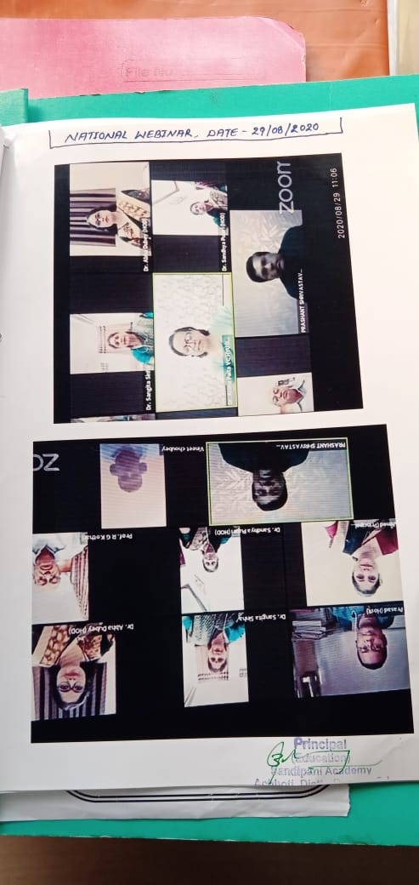
Under the aegis of Education Department of Sandipani Academy Achhoti, one day webinar has organized on topic – “Challenge & Opportunities of Higher Education System”. The chief guest of this webinar was Dr. Aruna Palta mam (Vice Chancellor of Hemchand Yadav Vishwavidyalay Durg, Chhattisgarh), Mentor Dr. Prashant Shrivastav (Adhisthata Chhatra Kalyan Hemchand Yadav Vishwavidyalay Durg, Chhattisgarh), Resource Person & keynote speaker Dr. Rameshchandra G. Kothari, Dr. Sangeeta Sinha (Savitribai Phule Govt. Post Graduate College Chakia, Chandauli, Uttarpradesh). The co-ordinators of this event were Mr. Vinod Sahu, Ms. P. Nagratnam, Ms. Varsha Rani Asst. Prof. of Sandipani Academy.
Also we extend our special thanks to our Hon. Director Mr. Mahendra Choubey, administrative officer Mr. Vineet Choubey, Head of Department Dr. Sandhya Pujari, Chief Advisor Dr. Abha Dubey and all the staff members who equally contributed for making this program successful.

NATIONAL WEBINAR

Event Name – Gender Sensitization
Date & Venue – 24 Apr 2021, Sandipani Academy Achhoti, Dist. – Durg (C.G.)

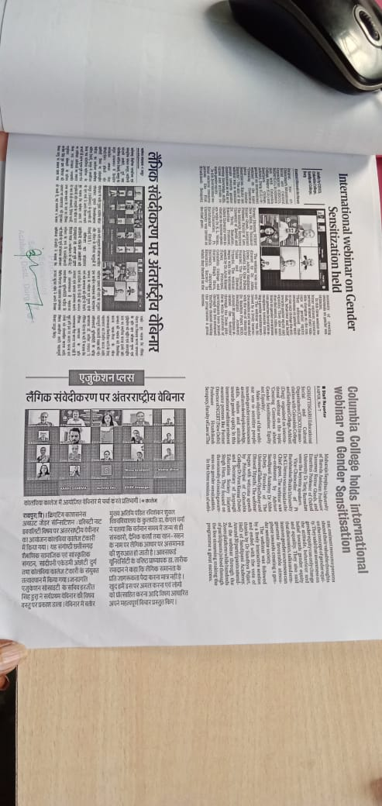
Under the aegis of Education Department of Sandipani Academy Achhoti, one day webinar has organized on topic – “Gender Sensitization”. The chief guest of this webinar & Keynote Speaker was Dr. Shishirkana Bhattacharya DIET, Achhoti, Durg (C.G.), in this event speaker delivered his though that how to raise kids in a Gender Neutral Environment. The co-ordinator of this event was Ms. Meena Pandey Asst. Prof. Sandipani Academy.
Also we extend our special thanks to our Hon. Director Mr. Mahendra Choubey, administrative officer Mr. Vineet Choubey, Head of Department Dr. Sandhya Pujari, Chief Advisor Dr. Abha Dubey and all the staff members who equally contributed for making this program successful.

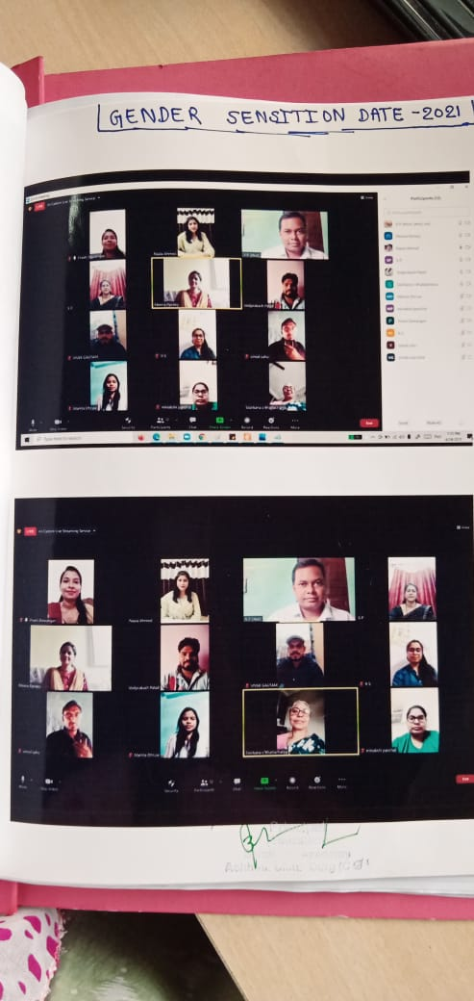

NATIONAL SEMINAR

Event Name – My Role in Environment Conservation
Date & Venue – 8th Jun 2021, Sandipani Academy Achhoti, Dist. – Durg (C.G.)

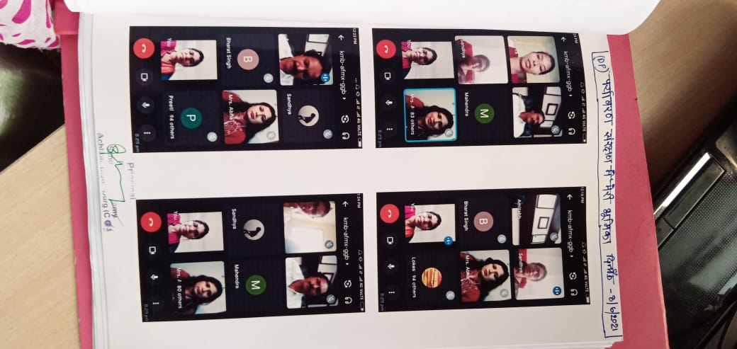
Under the aegis of Education Department of Sandipani Academy Achhoti, one day webinar has organized on topic – “My Role in Environment Conservation” & the Guest of honour of this seminar was Hon’ble CA Amitabh Dubey. The co-ordinators of this event were Ms. Preeti Dewangan, Ms. Vidya Chandrakar, Ms. Tripti Madhria & Ms. Mamta Dhruw Asst. Prof. of Sandipani Academy.
Also we extend our special thanks to our Hon. Director Mr. Mahendra Choubey, administrative officer Mr. Vineet Choubey, Head of Department Dr. Sandhya Pujari, Chief Advisor Dr. Abha Dubey and all the staff members who equally contributed for making this program successful

NATIONAL SEMINAR

Event Name – Yoga’s Impact in Our Life
Date & Venue – 25th Jun 2021, Sandipani Academy Achhoti, Dist. – Durg (C.G.)

Under the aegis of Education Department of Sandipani Academy Achhoti, one day webinar was organized on topic – “Yoga’s Impact in Our Life” & the chief guest of this webinar was Neera Pandey (Professor & H.O.D. Shri Shankaracharya Mahavidyalay Junwani, Durg CG), guest of speakers Dr. Kaptan Singh (Professor & DSWSRS University, Raipur C.G) & B.K. Aditi (Speritual organization Raipur C.G.). The co-ordinators of this event were Ms. Meena Pandey, & Ms. Kavita Patel Asst. Prof. of Sandipani Academy.
Also we extend our special thanks to our Hon. Director Mr. Mahendra Choubey, administrative officer Mr. Vineet Choubey, Head of Department Dr. Sandhya Pujari, Chief Advisor Dr. Abha Dubey and all the staff members who equally contributed for making this program successful.
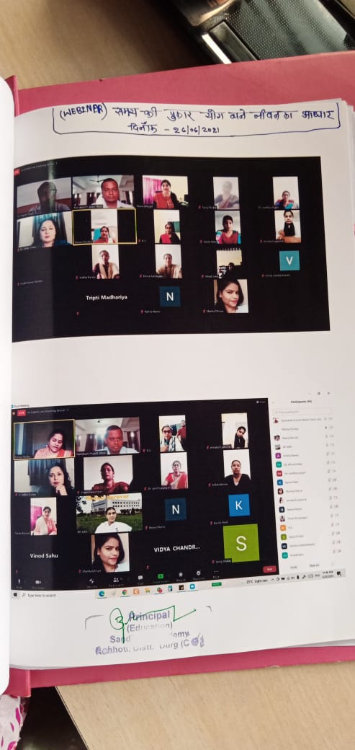

NATIONAL SEMINAR

Event Name – The Impact of New Education Policy(2020) on The Higher Education Sector
Date & Venue – 30 Nov 2021, Sandipani Academy Achhoti, Dist. – Durg (C.G.)

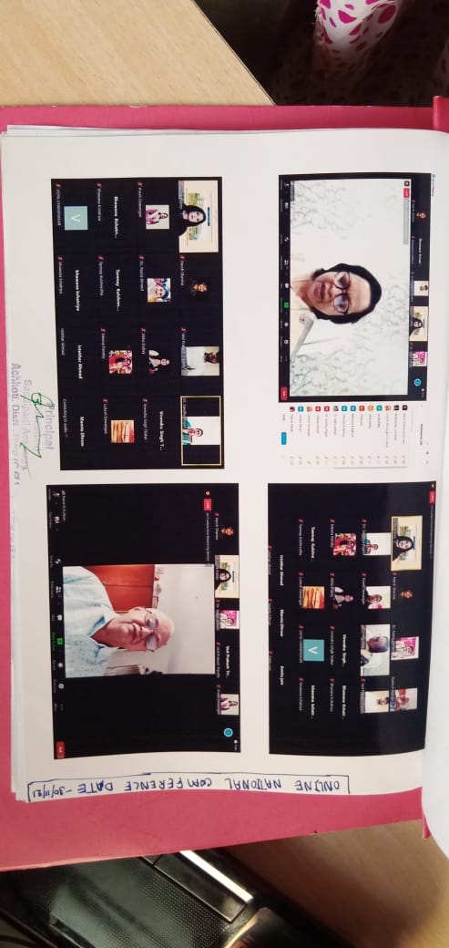
Under the aegis of Education Department of Sandipani Academy Achhoti, one day National Conference was organized on topic – “The Impact of New Education Policy(2020) on The Higher Education Sector” & the chief guest of this conference were Dr. Aruna Palta mam (Vice Chancellor of Hemchand Yadav Vishwavidyalay Durg, Chhattisgarh), Dr. Rameshchandra G. Kothari (Former Vice Chancellor, Veer Narayan South Gujrat Univrsity, Surat) & Dr. Kalpesh H. Pathak (Director, Principal, Centre of Education, IITE, Dean, Indian Institute of Teacher Education IITE, Gandhingar Gujrat ). The Co-ordinator of this Conference was Ms. Preeti Dewangan Asst. Prof. of Sandipani Academy.
Also we extend our special thanks to our Hon. Director Mr. Mahendra Choubey, administrative officer Mr. Vineet Choubey, Head of Department Dr. Sandhya Pujari, Chief Advisor Dr. Abha Dubey and all the staff members who equally contributed for making this program successful.

